Feedback from my optometrist

easy read form
The results
of my
eye test

Using this form – There are two ways of filling in this form:

- It can be printed off and written on

- It is a Word document that can be filled in and saved on computer using Adobe Acrobat reader

To find it online go to : www.seeability.org

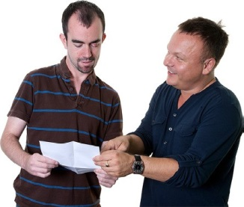
I need my optometrist (optician) to fill in this form

It will help me and my supporters to understand my eye sight and the health of my eyes

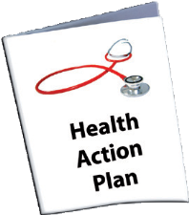
This form includes my
prescription (GOS 2)

This form should be kept in my health action plan

Section 1 – Details of me and my optician

My Name:

My optician’s name
and address:

Page 1
Section 2 – Dates of my eye tests

Date of this test:

Date of next test:
(recommended)

Section 3 – My prescription

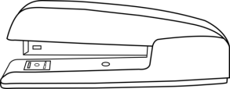
Please either fill in the prescription on this
form or attach the prescription here

Results of Eye Test |  |  |  |  |  |  |  | Date:
R  i g h t |  | Unaided Vision | Sph | Cyl | Axix | Prism | VA | Unaided Vision | Sph | Cyl | Axix | Prism | VA | L  e f t
 | Dist
 | Near
 | Acuity method or description of functional vision

Section 4 – Which testing method was used?

Please say which testing method you used:
Standard test

Kay pictures

Sheridan Gardiner Test

Cardiff Acuity cards

Snellen

Other – please say
Page 2
Section 5 – Please tell me about the health of my eyes

The health of my eye lids and lashes

They are ok

There is a problem – please say more below

The health of the front part of my eyes (for example my cornea,
conjunctiva)

They are ok

There is a problem – please say more below

The health of the inside of my eyes (for example my retina, lens, iris)

They are ok

There is a problem – please say more below

The pressure in my eyes (if this was measured)

They are ok

There is a problem – please say more below

Page 3

Did the eye test find any other health problems?

No

Yes – (for example diabetes or anaemia) – please say
more below

Do I need to see anyone else about problems with the health of my eyes?

No

Yes – (for example my GP) – please write down who I
should see

Section 6 – Please tell me about my eyesight

Tick any of the boxes below that apply to me, I am:

Short sighted – can’t see things far away very well

Long sighted – can’t see things up close very well

Astigmatic – this can cause blurred vision

Presbyopic – as we get older, we can have difficulty
seeing close objects

Not needing glasses at all

Please say more
here if needed:

Page 4
Please tell me about my visual acuity (This is how clearly I can see details)

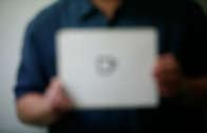
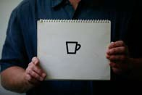

This is ok

There is a problem

Please say more below

Good clear vision Poor vision

Please tell me about my binocular vision (How well my eyes work together)

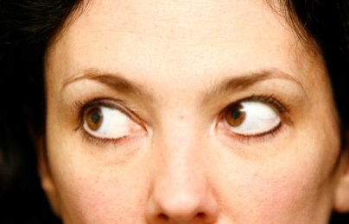

This is ok

There is a problem

Please say more below
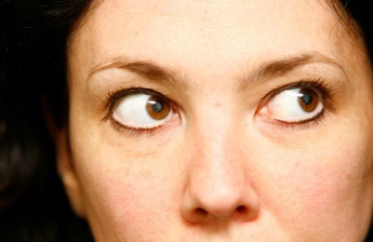

Please tell me about my colour vision (If this was tested)

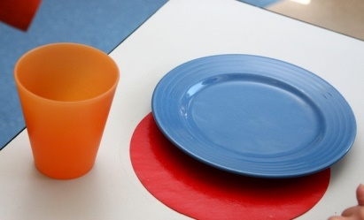

This is ok

There is a problem

Please say more below
This was tested

This was not tested

Page 5
Please tell me about my contrast sensitivity (if this was tested)
This is about how well I see objects against different backgrounds

This is ok

There is a problem

Please say more below
This was tested

This was not tested

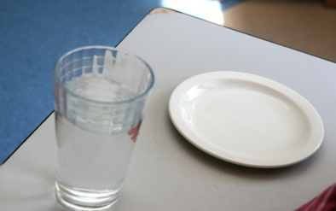

Please tell me about my sight when it’s light or dark

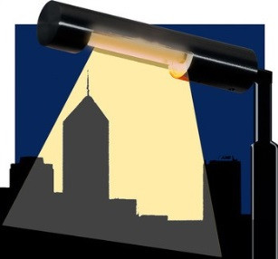
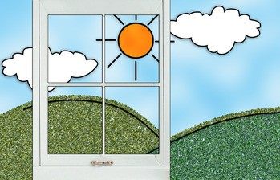
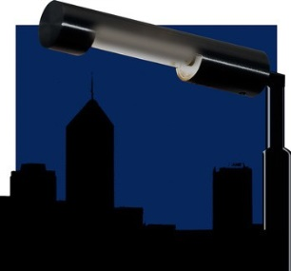

Please tick any boxes that apply

My vision is okay all the time

My vision is better in daylight

My vision is not good in the dark

I have no vision in the dark

Please write more in the box below

Page 6

Section 7 – Please tell me the sight in my right and left eye
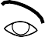

Right eye
Left eye
It is ok
It is ok
There is a problem
There is a problem
Which eye has better sight?
Right
Left
Same
Section 7 - Please tell me the sight in my right and left eye
Please say more here

Please say more here

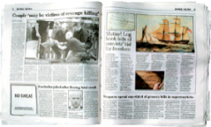
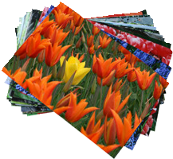
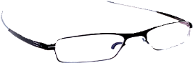
Section 8 – Please tell me about my glasses

These glasses are for:

Looking at things near to me
Like reading and looking at photos

Looking at thigs further away from me
Like watching TV or looking at a view

Looking at things both near and
far away

Please tell me about my first pair of glasses (These may be my only pair)

Page 7
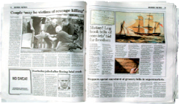
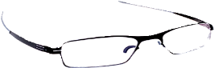
Please tell me about my second pair of glasses (If I have a second pair)

These glasses are for:

Looking at things near to me
Like reading and looking at photos

Looking at thigs further away from me
Like watching TV or looking at a view

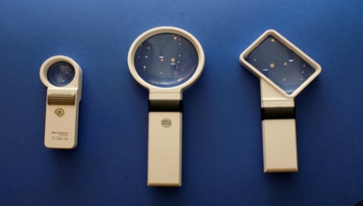

Low vision aids are tools like magnifying
glasses and lamps and will help me with seeing
Should I use low vision aids?

No

Yes (please say where I can get them and who can help me use them)
Section 9 – Low vision aids

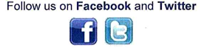
www.seeability.org

Page 8
Reviewed: January 2018

