easy read form
Eye Surgery Support Plan

easy read form

Introduction

Adults with learning disabilities are 10 times more likely to have sight problems but less likely to have eye surgery.
Eye surgery means having an operation to help with an eye problem

You can use the Eye Surgery Support Plan to get ready for your eye surgery. You can share it with your carers and the hospital too

What is in the plan?

Introduction
Section 1 - Your information
Section 2 – Getting ready for eye surgery Section 3 – After the surgery
Section 4 – People involved in my eye surgery

SeeAbility is the operating name of The Royal School for the Blind founded in 1799. Registered Charity Number 255913
© SeeAbility 2017. No part of this document can be altered or changed without permission
Page 1

easy read form
Eye Surgery Support Plan

Information about my eye surgery easy read form

Section 1 – Your Information
Please fill in this form when planning your surgery

Hospital number:
Date of birth:
Telephone:
Your Address:
Your name:
Personal details
Feedback from an Eye Clinic Appointment
SeeAbility has a form to help you gather this information:
Details of eye surgery

SeeAbility is the operating name of The Royal School for the Blind founded in 1799. Registered Charity Number 255913

© SeeAbility 2017. No part of this document can be altered or changed without permission
Page 2

Details of eye surgery
Name of eye condition:

Type of surgery:

Purpose of surgery:

Which eye?
Right Left

Name of hospital:

Name of eye consultant:

Date of pre-assessment appointment:

Date of surgery:

Type of Anaesthetic: (Please tick)
Local anaesthetic – you will be awake during the surgery but you will not feel anything

General anaesthetic – you will be asleep during the surgery

Other – please describe

SeeAbility is the operating name of The Royal School for the Blind founded in 1799. Registered Charity Number 255913

© SeeAbility 2017. No part of this document can be altered or changed without permission
Page 3

Time to be at the hospital on the day of your surgery
stay for a few days
stay overnight
just for the day
Length of time in hospital:
Details of eye surgery

Acute Learning Disability Liaison Nurse
Consultant’s Secretary
Eye Clinic Liaison Officer
Contact people at the hospital
Name:
Phone Number: Email:
Name:
Phone Number: Email:
Name:
Phone Number: Email:

SeeAbility is the operating name of The Royal School for the Blind founded in 1799. Registered Charity Number 255913
© SeeAbility 2017. No part of this document can be altered or changed without permission
Page 4

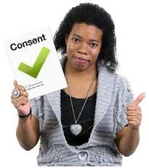

We have a factsheet about Consent and Capacity
Unsure
No
Yes
Consent is being asked if you agree to something. This means saying yes or no. Having an operation is a big choice and you might need help to say yes or no

Do you think you might need help to make a choice about having an eye operation?
Capacity and consent

What support do you need with your vision before the surgery?
Sometimes your sight may get worse until you have your operation. This can affect the support you might need.
SeeAbility’s Functional Vision Assessment tool can help you and your carers to find out how much you can see and think about any problems you might have

Think about: Communication Moving around safely Accessing information
Support with medication

SeeAbility is the operating name of The Royal School for the Blind founded in 1799. Registered Charity Number 255913
© SeeAbility 2017. No part of this document can be altered or changed without permission
Page 5

easy read form

Getting ready for your eye surgery easy read form
My Eye Surgery Support Plan

Section 2 – Getting ready for Eye Surgery

This section suggests areas where you may need support. It is important to plan your support before your have your eye surgery

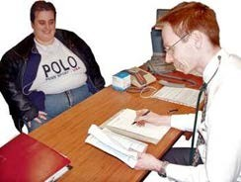
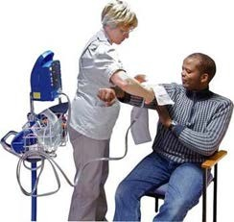
Pre-operative checks

The hospital will need to do some checks before the operation. Here is a list of some of the tests and assessments they may do:

Medical history - doctors or nurses may ask you some questions about your health. They might ask if you have had any operations before

Blood pressure – your heart pumps blood around your body. You will need to have your blood pressure taken to make sure you are healthy

SeeAbility is the operating name of The Royal School for the Blind founded in 1799. Registered Charity Number 255913
© SeeAbility 2017. No part of this document can be altered or changed without permission
Page 6

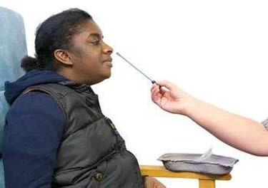
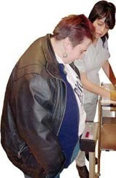
Pre-operative checks
Electro Cardiogram (ECG) – to check your heart is healthy. Sticky pads are put on your chest which check if your heart is healthy

Blood tests - A doctor or nurse might take some blood from your arm using a needle and container. It might hurt a little. They test the blood to make sure you are healthy
Check your lungs and heart. Your doctor will use a stethoscope to listen to your breathing

Height – to see how tall you are Weight - to see much you weigh

Urine - you produce urine when you use the toilet. Doctors might need to check your urine to make sure you are healthy

MRSA test - MRSA is a type of germ. Doctors need to test if you have MRSA by taking a swab from part of your body such as your nose

Intraocular lens measurement (IOL) – this is for cataract surgery only. Inside your eye is a lens which helps you see. Having a cloudy lens is called a cataract. The cloudy lens in your eye will be replaced by a clear lens. The doctor will need to measure your eye to make sure they give you the right strength lens

SeeAbility is the operating name of The Royal School for the Blind founded in 1799. Registered Charity Number 255913
© SeeAbility 2017. No part of this document can be altered or changed without permission
Page 7

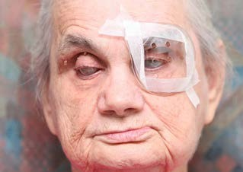
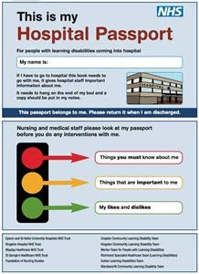
Supporting you to get ready for eye surgery

Here are some ideas on how to get ready for your eye surgery
- Find out how long you will need to stay in hospital
- Find out if you are having a local or general anaesthetic

- Talk to the Consultant’s secretary or booking clerk about what time you should go to the hospital

- Practice getting up early
- Practice wearing the eye patch
- Visit the hospital before the day of surgery to get used to the journey and the hospital environment

- Practice having eye drops using artificial tears
- Practice shining lights around the eyes
- Fill in the hospital passport. This gives hospital staff important
information about you and your health

- Use SeeAbility’s eye care easy read information
- Work with a Speech Therapist to use photos that help explain what will happen

SeeAbility is the operating name of The Royal School for the Blind founded in 1799. Registered Charity Number 255913
© SeeAbility 2017. No part of this document can be altered or changed without permission
Page 8

Things to plan for the day of your operation
Think about these things before you go to hospital to make sure that everything is ready on the day of your operation
Time to be at hospital – think about how this will change your usual routine

You may not be allowed to eat or drink before the operation – think about what support you will need with this

Plan how you will travel to the hospital and how you will travel home

Decide who will travel with you

Work out who will stay with you before, during and after your operation

SeeAbility is the operating name of The Royal School for the Blind founded in 1799. Registered Charity Number 255913
© SeeAbility 2017. No part of this document can be altered or changed without permission
Page 9

What should you take to the hospital?

You may need to stay in hospital overnight. Here is a list of things you might need to take to the hospital

- Pyjamas

- Dressing Gown

- Change of underwear and clothes

- Incontinence pads (If needed)

- Toiletries

- Hospital passport to give to hospital staff

- Medication or list of medication

- Essential aids – glasses, hearing aid, any other communication aid

- Personal stereo, magazines, familiar objects, etc

- Anything else?

SeeAbility is the operating name of The Royal School for the Blind founded in 1799. Registered Charity Number 255913

© SeeAbility 2017. No part of this document can be altered or changed without permission
Page 10

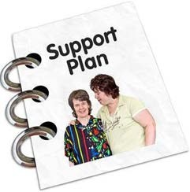
After the surgery

Section 3 – After the surgery

These questions will help you to plan what care you will need after your surgery

How long will you need to rest and take a break from usual activities after the operation?

What extra support will you need? You may need 1 to 1 support to remind you not to rub your eyes. Funding for this should be agreed before your surgery by your Care Manager or Social Worker

Will you need to wear an eye patch and for how long?

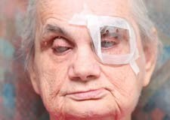
SeeAbility is the operating name of The Royal School for the Blind founded in 1799. Registered Charity Number 255913
© SeeAbility 2017. No part of this document can be altered or changed without permission
Page 11

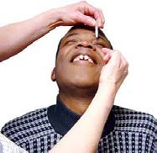
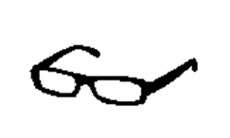
Things to plan for returning home

Eye drops – how often are they needed, how long for and who will help you with this?
SeeAbility has an easy read factsheet about taking eye drops
www.seeability.org/looking-after-your-eyes

Make sure that you have some quiet activities to keep you busy, to help stop you from touching your eyes

When is it OK to wash your hair and have a shower after your operation?

What pain relief will you need?

When is the follow-up appointment at the hospital?

Will you need to wear glasses after the operation?

SeeAbility is the operating name of The Royal School for the Blind founded in 1799. Registered Charity Number 255913

© SeeAbility 2017. No part of this document can be altered or changed without permission
Page 12

Other useful resources – click on the links below

SeeAbility’s Feedback from an Eye Clinic Appointment form

SeeAbility’s Consent and Capacity Easy Read factsheet

SeeAbility’s Functional Vision Assessment tool can help you and your carers to monitor any changes to your vision after your surgery

SeeAbility’s Easy Read Books

SeeAbility Consultancy

The Hospital Communication Book and Pre Hospital Communication Guide are available from:

http://www.communicationpeople.co.uk/

Accessible health information is available from

http://easyhealth.org.uk/

www.seeability.org/sharing-knowledge

SeeAbility is the operating name of The Royal School for the Blind founded in 1799. Registered Charity Number 255913
© SeeAbility 2017. No part of this document can be altered or changed without permission
Page 13

easy read form
People involved in my eye surgery easy read form
My Eye Surgery Support Plan

Section 4 - People involved in my eye surgery

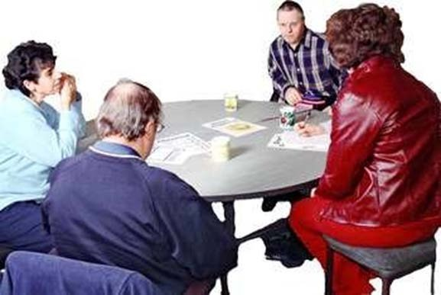

Who should be involved in planning your eye surgery with you? There are lots of people who can support you to have eye surgery. Here is a list of people who can help
Things to plan for returning home

SeeAbility is the operating name of The Royal School for the Blind founded in 1799. Registered Charity Number 255913
© SeeAbility 2017. No part of this document can be altered or changed without permission
Page 14

The person – That’s you!
The person having the eye surgery

Family and Friends - people that are important to you

Key Worker / Support staff / Manager – these are the different staff who may support you

General Practitioner (GP) – this is your usual doctor that you might see if you are feeling unwell

Care Manager / Social Worker – helps you plan your care and support

Health facilitator – often works with Community Learning Disability Team (CLDT) and can support you with your health needs

SeeAbility is the operating name of The Royal School for the Blind founded in 1799. Registered Charity Number 255913

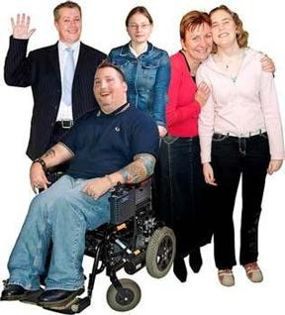
© SeeAbility 2017. No part of this document can be altered or changed without permission
Page 15

People involved in my eye surgery

Community Learning Disability Nurse – can give you advice and support with your health, life skills and social activities
Occupational Therapist – can help you to be more independent with everyday activities like moving around safely

Speech and Language Therapists – help people who find it difficult to communicate or to eat and drink

Learning Disability Psychologist – can support you with things like what to do when you feel angry

Advocate – can help you to make choices about your life

Rehabilitation Officer for People with a Visual Impairment / Rehab Worker – can give you advice or training if you have a visual impairment. Rehab Workers may be part of the Sensory Team and can be contacted at your local Social Services department.

Eye Clinic Liaison Officer (ECLO) – work in hospital eye clinics and can give you advice and information about different eye care services

Acute Learning Disability Liaison Nurse – work at the hospital and can help you to plan your hospital care

SeeAbility is the operating name of The Royal School for the Blind founded in 1799. Registered Charity Number 255913

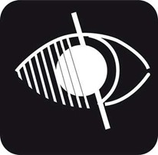
© SeeAbility 2017. No part of this document can be altered or changed without permission
Page 16

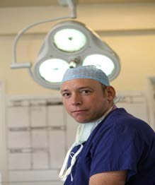
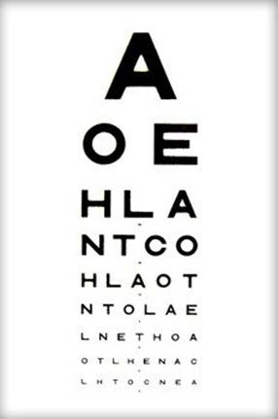
People involved in my eye surgery

Consultant Ophthalmologist – this is the eye doctor at the hospital eye clinic

Anaesthetist – you may need medicine to make you sleepy or drowsy before your surgery. This is called an anaesthetic. The anaesthetist and the eye doctor will help you to decide what anaesthetic is best for you

Hospital booking clerk or administrative support – help you to book the dates of your appointments and your eye surgery

Optometrist – the person who can give you an eye test. They check your eyesight and the health of your eyes. This person may also be called an optician

Nurse – someone who is trained to look after people when they are in hospital

SeeAbility is the operating name of The Royal School for the Blind founded in 1799. Registered Charity Number 255913
© SeeAbility 2017. No part of this document can be altered or changed without permission

Page 17

SeeAbility works to transform eye care and vision of people with learning disabilities

This Eye Surgery Support Plan is endorsed by:

“The SeeAbility ‘Eye Surgery Support Plan’ is clear, helpful, and informative and will help patients, their families and carers to better understand and anticipate what undergoing eye surgery involves. It will underpin the advice given by hospital staff and be a useful reference throughout the patient’s journey”

01372 755 045
myeyecare@seeability.org
www.seeability.org/looking-after-your-eyes

SeeAbility runs training courses for hospital eye clinic staff. For more information about SeeAbility's training courses, click here

Reviewed: December 2017
SeeAbility is the operating name of The Royal School for the Blind founded in 1799. Registered Charity Number 255913

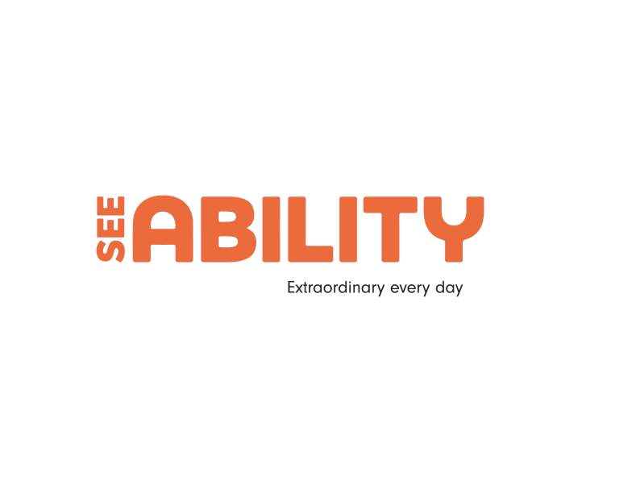
© SeeAbility 2017. No part of this document can be altered or changed without permission
Please contact us for copies of our literature in accessible formats

SeeAbility is the operating name of the Royal School for the Blind founded in 1799 Registered Charity No. 255913
www.seeability.org
Page 18

